Case 10-MEX-Olmec-Mask-Serpentine-1100 BCE

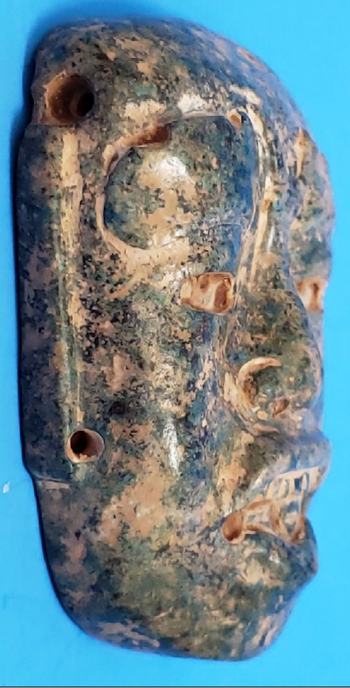 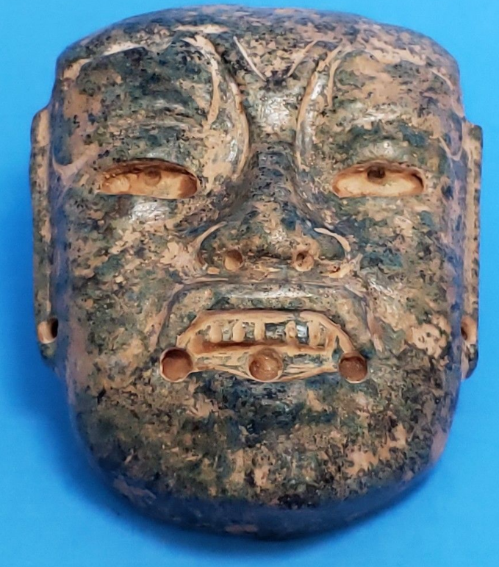 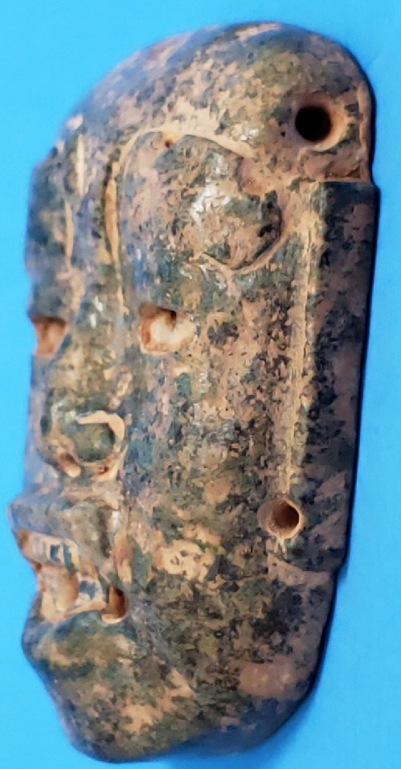 

**Case no.: 14**

**Accession Number:**

**Formal Label:** MEX-Olmec-Mask-Serpentine-1100 BCE

**Display Description:**

This is a jaguar transformation mask which emphasizes the feline wrinkles around the nose and the upcurving lips. It also had hair that was lodged in three drill holes along the lower lip. It was probably worn around the neck as a pendant and may have given the wearer a new identity, perhaps that of the were-jaguar ancestor, because the Olmecs believed that, in the distant past, a union between a woman and a jaguar produced an earlier race of were-jaguars.

The Olmecs worked mainly in stone and used mottled serpentine to suggest the transformative aspect of the spiritual were-jaguar conversion.

**LC Classification:**

**Date or Time Horizon:** 1100 BCE

**Geographical Area:** possibly La Venta area

**Map:**

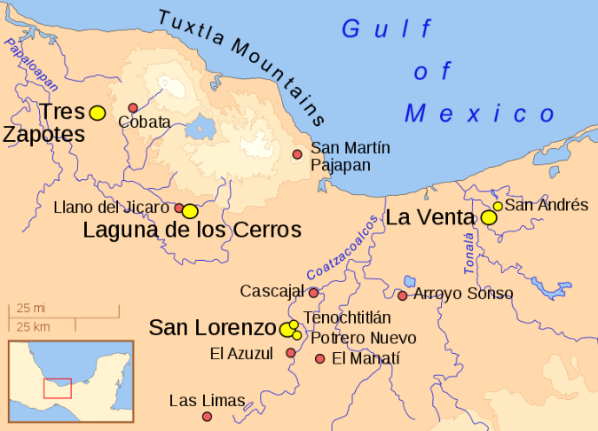

**GPS coordinates:**

**Cultural Affiliation:** Olmec

**Medium:** jade

**Dimensions:** 2 3/4 "TALL  2 1/4" WIDE

**Weight:**

**Condition: original**

**Provenance:**

**Discussion:**

The Olmecs, the earliest known settled civilization of Central America, lived in the low-lying Gulf Coast area of what is now Mexico in about 1200-400 BCE at sites such as San Lorenzo, Tres Zapotes, Laguna de los Cerros and La Venta.

These and the other Olmec centers were well-planned and included many of the features that would be associated with later civilization in Central America including the Mexica (Aztecs) and Maya. Alongside impressive public spaces and large platform-mounds made of earth, there is evidence of a ceremonial ball game and complex astrological calendars.

**References:**

Bernal, Ignacio. 1976. The Olmec World. Berkeley, CA: University of California Press.

Campbell, Lyle and Terrence Kaufman. “A Linguistic Look At The Olmec.” American Antiquity. Vol. 41, January, 1976, p. 80-89.

Coe, Michael D. 1994. From The Olmecs To The Aztecs. 4th ed. London: Thames & Hudson, 1994.

— . 1996. The Olmec World: Ritual and Rulership. Princeton, NJ: The Art Museum, Princeton University.

Drucker, Philip, Robert F. Heizer, and Robert J. Squier.1959. “Excavations At La Venta, Tabasco, 1955.” Bureau Of American Ethnology. Bulletin 170.

Grove, David C. 1984. Chalcatzingo: Excavations On The Olmec Frontier. London: Thames & Hudson.

Luckert, Karl W. 1976. Olmec Religion: A Key To Middle America And Beyond. Norman, OK: University of Oklahoma Press.

Miller, Mary and Karl Taube. 1993. The Gods And Symbols Of Ancient Mexico And The Mava: An Illustrated Dictionary of Mesoamerican Religion. London: Thames & Hudson.

Sharper, Robert J. and David C. Grove, eds. 1989. Regional Perspectives On The Olmec. NY: Cambridge University .

Soustelle, Jacques. 1984. The Olmecs: The Oldest Civilization In Mexico. Garden City, NY: Doubleday & Company.